1. Launch the application
2. Select “Virgo Classic Gyro button from the “Entrees” menu

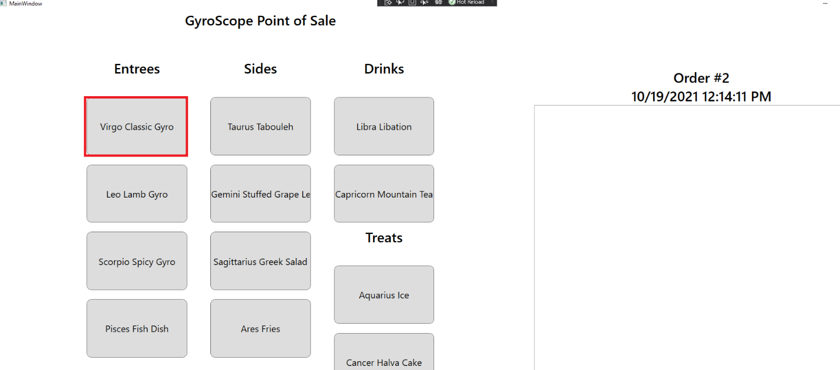

1. Following customization screen should look like the next picture:

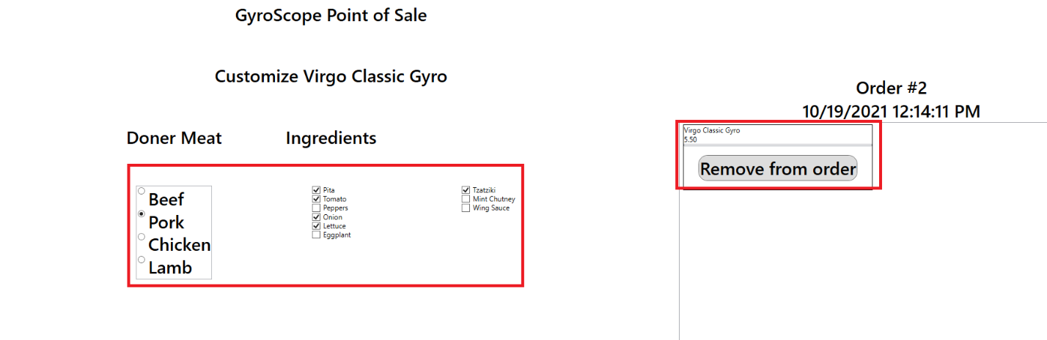

1. A corresponding “Use Beef” detail as well as “Hold Tzatziki” and “Add wing sauce” should appear since those ingredients are different from the default.

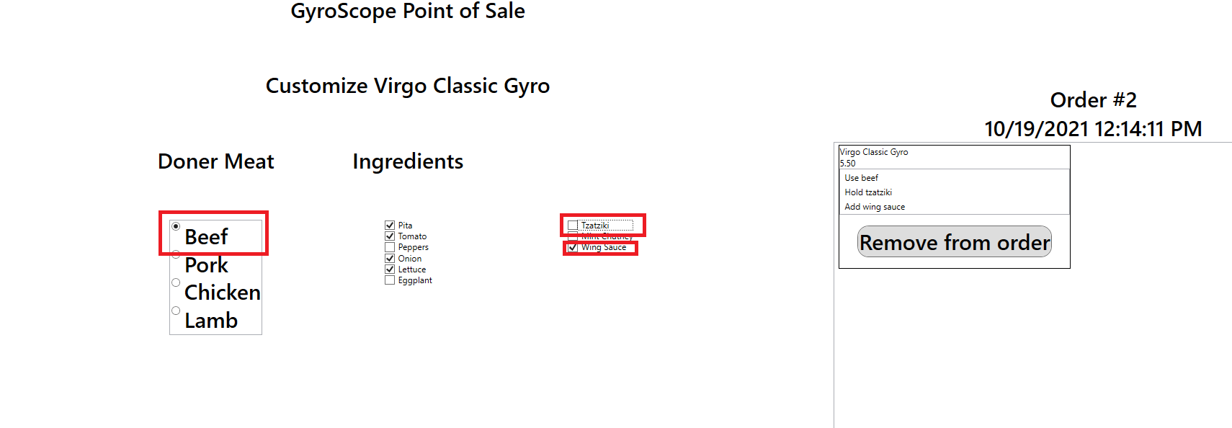

1. Adding this order should change the subtotal, tax and total of the order.

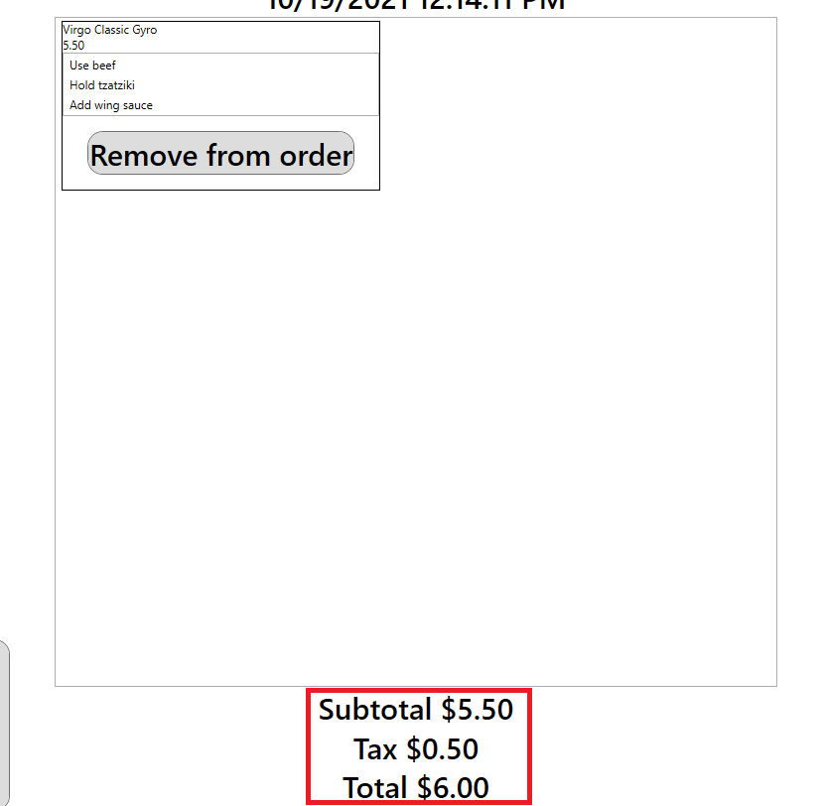

1. Click the “Select Items” button to add the item to the order. It will bring you to the previous menu to select a new item, cancel order, or complete order for the items in the order.

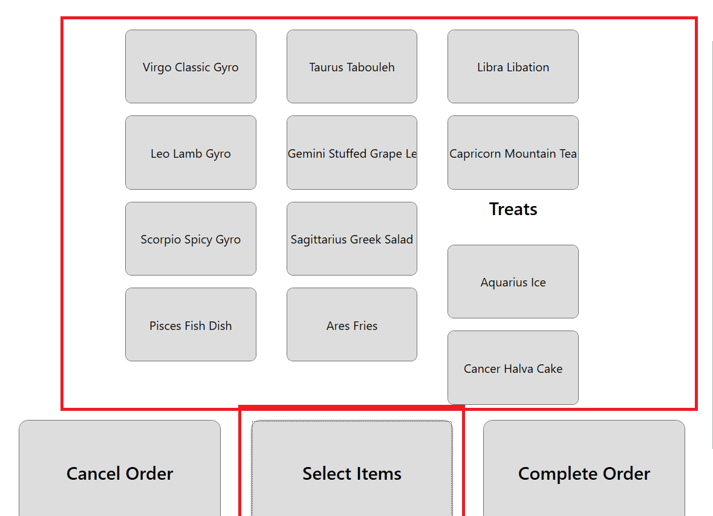

1. Next pick the “Taurus Tabouleh” Side item. It should add it to the order along with a menu for you to pick the size.

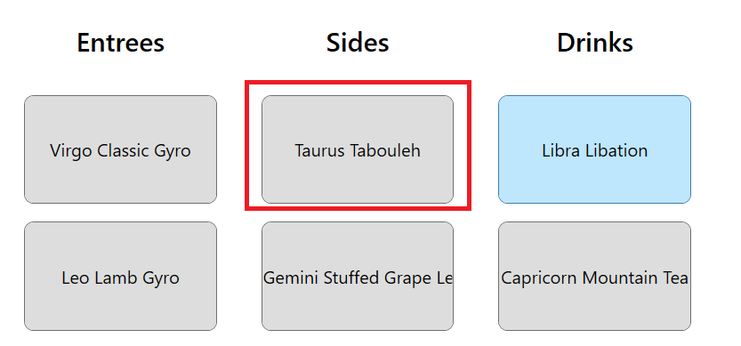

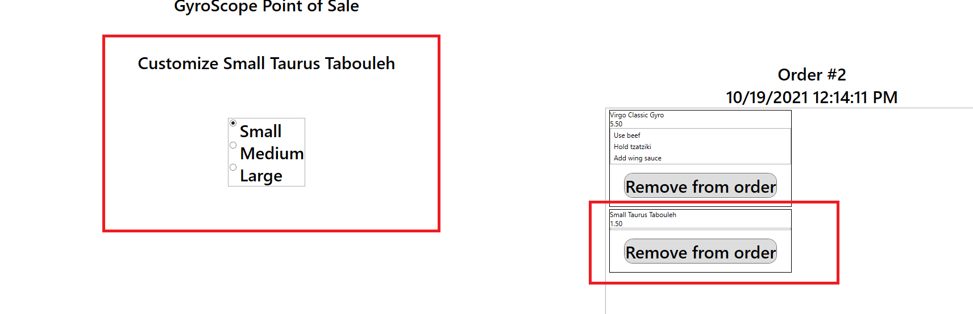

1. Click “Medium” size and the price should change to $8.18.

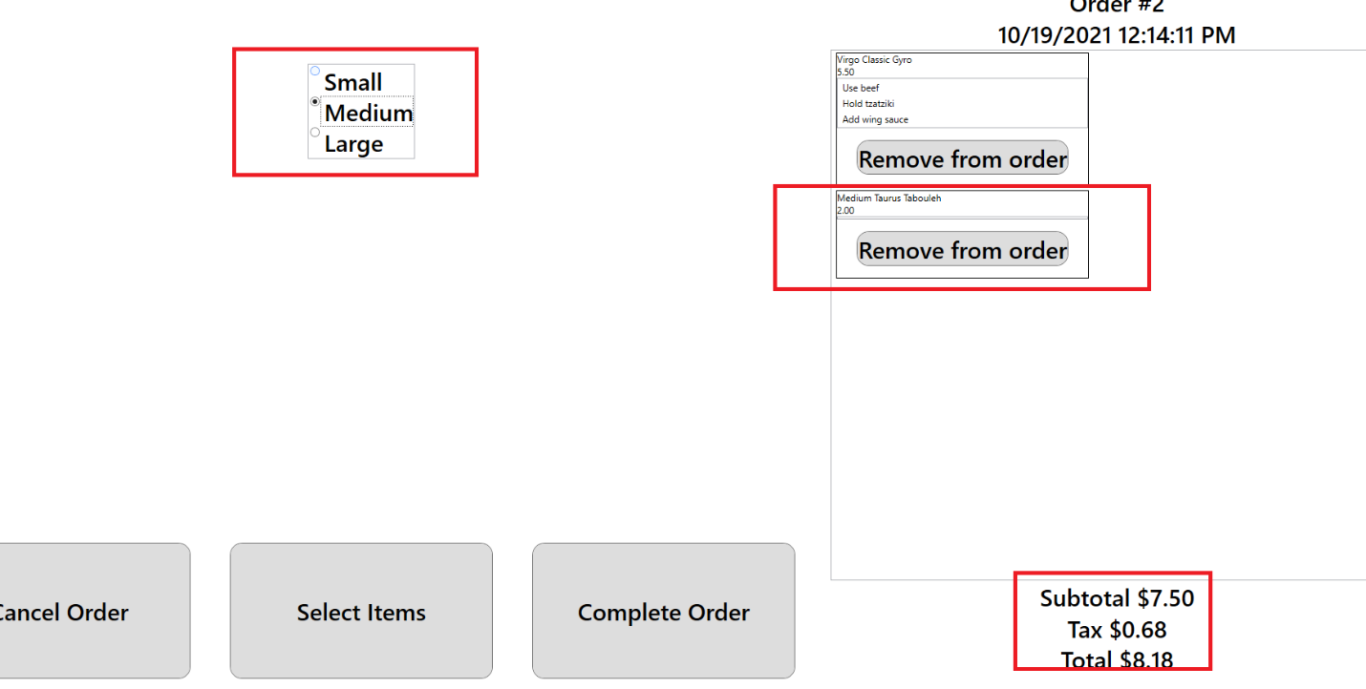

1. As for the last item, select “Select Item” to bring back to the main menu of items. Then select “Libra Libation” from the drinks menu.

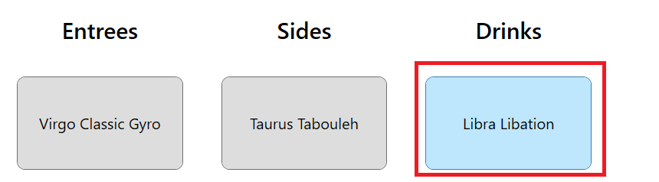

1. Selecting this item should add it to the order and change the price to $9.27

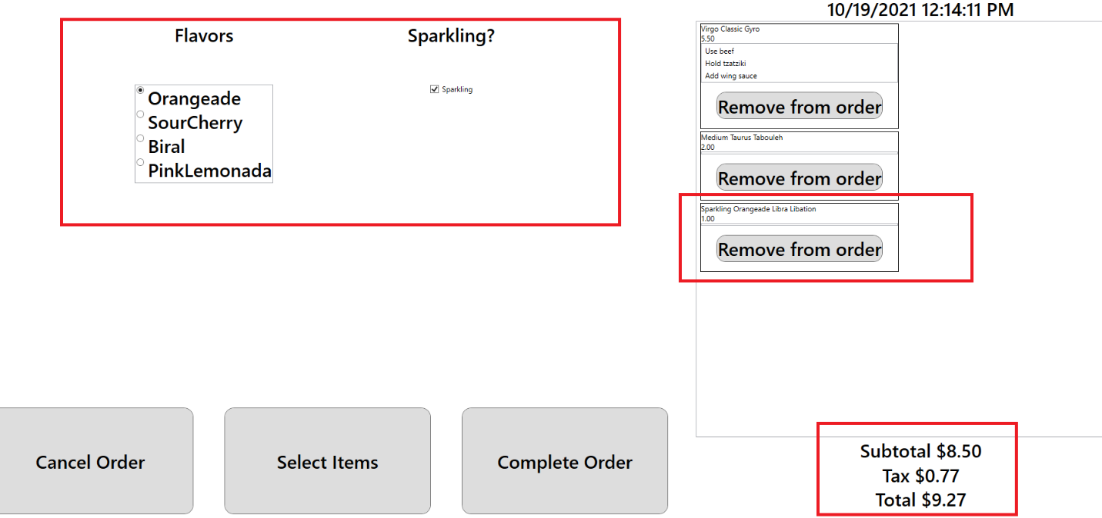

1. Change the flavor to “Biral” and uncheck “Sparkling. This should change the name to “Still Biral Libra Libation”.

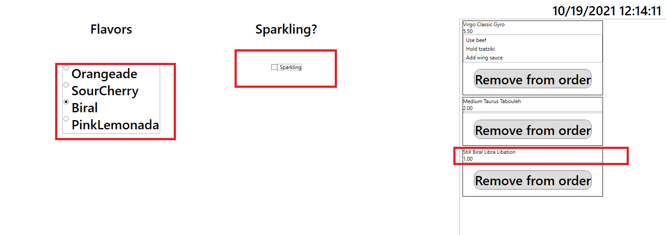

1. Select “Select Item” to bring back to the previous screen to choose the last item.

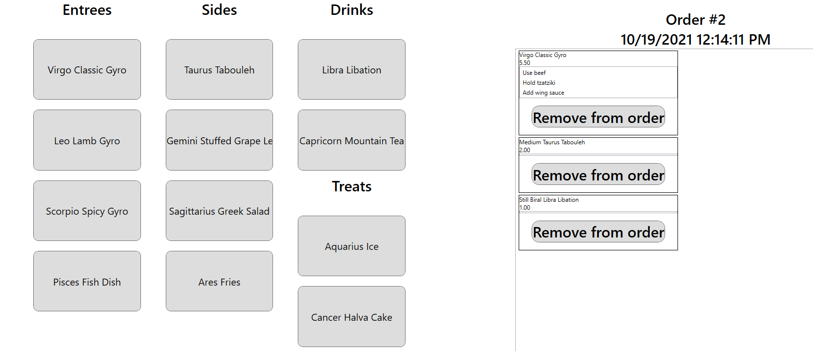

1. Select “Aquarius Ice” from the menu. This will bring up the customization screen for size and flavor of Aquarius Ice as well as add it to the order, changing the total to $11.45

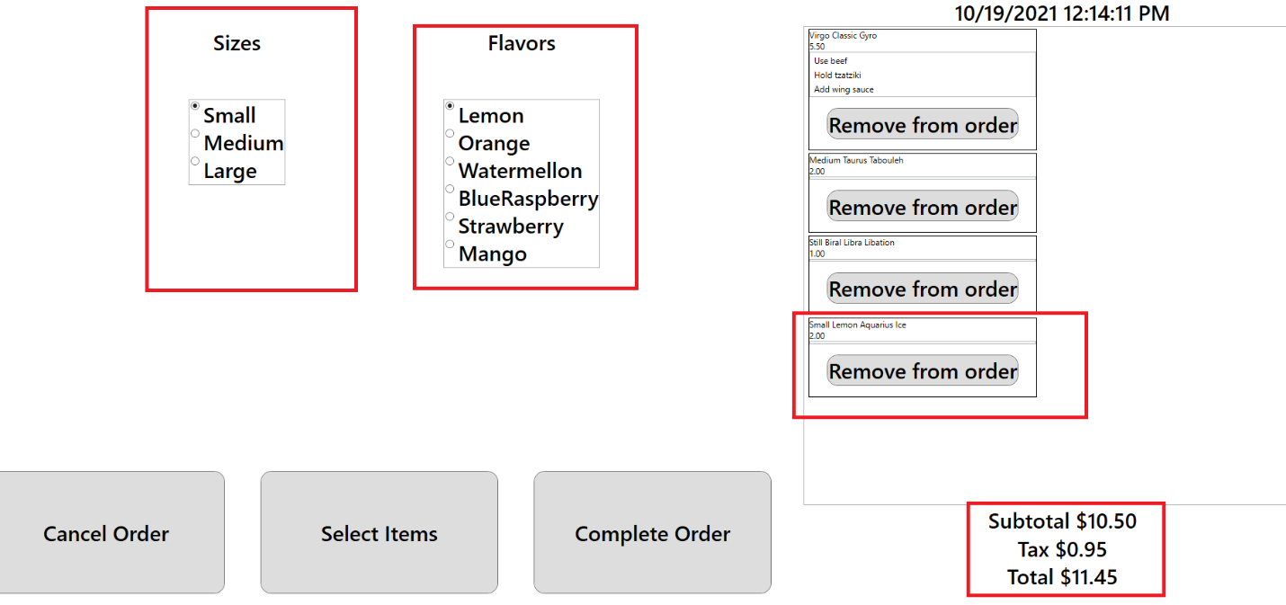

1. Change the size to large and the flavor to mango. This should change the price to $12.54 and the name will be “Large Mango Aquarius Ice”.

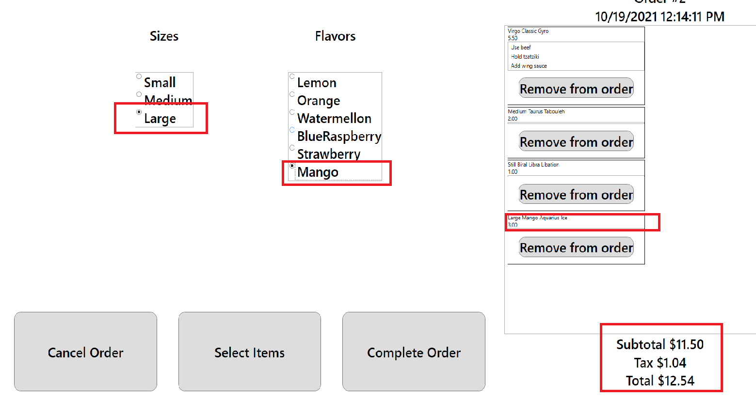

1. Click “Select Items” to add it to the cart for later. It will bring up the main menu.

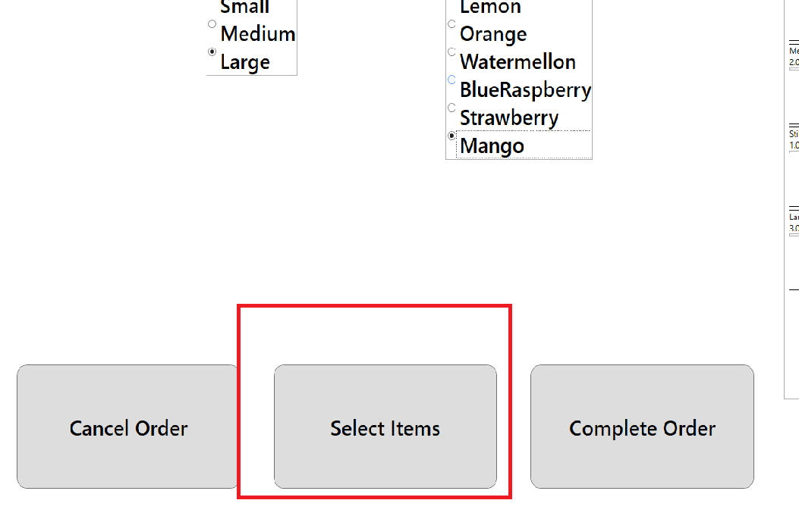

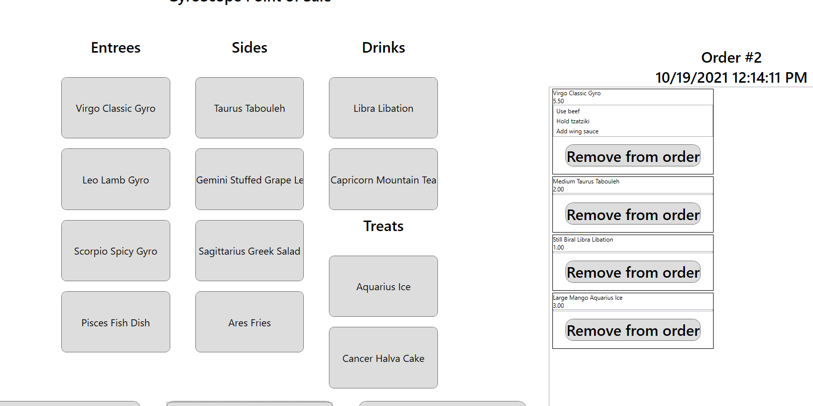

1. Click “Complete Order” to finish the order and pay for the items in the cart. This will empty out the order and change the order number to the next order in line. Thank you for shopping!

